An unequivocal benefit of the medium of self-care is that once you begin you are more readily able to recognise when you can apply self-care principles. Also, how to administer that care, using various actions and combinations which can be easily woven into your daily life. Taking the lead from Maslow’s hierarchy of needs; at its most reduced level is the basic human psychological need for survival. This foundation level requires us to obtain food, water, warmth, and rest in order for those fundamental needs to be met. Therefore, these elements can apply as inspiration and introductory cornerstones for beginning to administer self-care.

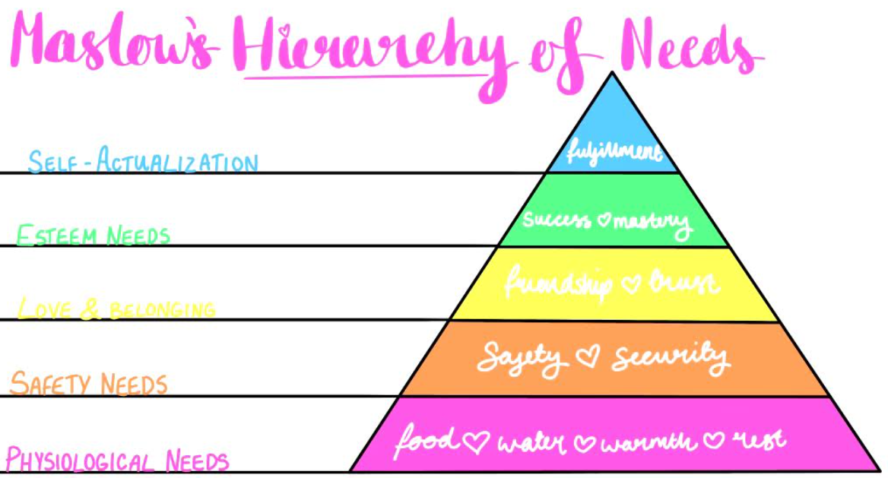

The suggestions in this worksheet are designed to be undertaken throughout the day, collectively amounting to 30 minutes. However, there is no reason why you cannot carry out multiple suggestions in a shorter timeframe, for example a 30-minute period. Once you become more familiar you will be able to call upon your preferred self-care acts. Please note there is no hard and fast rule to self-care. Although, we must acknowledge individual differences: what works for one person can be less effective for another. As with most things, try different forms of self-care to locate the sweet spot. Moreover, allow acknowledgement of kind gestures that you are consciously making towards oneself. For example, if you chose to go to bed early; you are doing so in the name of self-care.

Morning ‘I will’ check in
Nourish my body with nutritious food
Remember to focus on hydration
Acknowledge gratitude for at least one thing a day
Prioritise rest (or sleep)

Daily do’s (or at least tries):
Take a walk.
If outside, acknowledge the warmth of the rays on your skin.
Take deep ‘conscious’ breaths
Saying ‘no’ if you say ‘yes’ more than you should.
Stretching in a seated position.
Seeing or hearing from a friendly face.

Extra sprinkles of self-care:
Apportion some ‘me time’ once a week.
Chose those you spend time with and perhaps consciously decide to spend time with those who are kind or positive, or both.
Celebrate wins however small they maybe.
Speak to yourself as though you are speaking to a friend. In essence, lessening focus on the inner critic, while working towards more positive affirmations. This is showing oneself kindness, rendering self-care. For example, I am worthy, I am a good friend, I make the best chocolate brownies or anything else that comes to mind where you are recognising and championing your greatness and strengths.

Evening thoughtfulness:
Running a warm bath (bubbles optional)
Moisturising your skin and being aware of your own touch
Create some space away from devices or electronics
Read before bed

Final thoughts:
Please remember that Rome was not built in a day. Like all skills, the skill of self-care is an ever-evolving practice which takes self- kindness, repetition, patience, and time.

Note to future self:
I wish you to know that the attempts of self-care I make today are motivated by the knowledge that I one day will reflect to this day and acknowledge how far I have come.

